Prediction of Oxidation Behaviour of Refractory High Entropy
Alloys: A Machine Learning Study
GVSS Manoj Kumar, Syed Mohammad Musthaq, Rahul Mitra, Shikhar Misra and Krishanu Biswas
Department of Materials Science and Engineering, Indian Institute of Technology, Kanpur, Uttar Pradesh, India – 208016

Abstract
Due to the lack of relevant systems, oxidation prediction in Refractory high entropy alloys (RHEAs) systems using machine learning has been limited. To address these concerns, ADASYN oversampling technique has been utilized to predict the oxidation rate constants of RHEAs using statistical machine learning models and comparing it with experimental findings. Due to experimental reliance, a two-step modeling was used to predict the oxidation rate exponent (n) followed by the rate constant (k). A five-fold cross-validated Extra Tree model was used to achieve ~ 96% testing accuracy on predicting rate exponent whereas a RandomForest model was trained to achieve ~ 98% testing accuracy on predicting the rate constant. An isothermal oxidation study was carried out for 6h at 1300°C on five newly synthesized RHEA compositions to validate the predictive capability. The experimental results were found to have good agreement while predicting both the rate exponent and rate constant values. A few discrepancies were also observed owing to the microstructural characteristics of the alloys. Nonetheless, such ML models can provide an initial foundation for understanding the oxidation behavior of neo-RHEAs without undergoing rigorous experiments.
Keywords: Refractory high entropy alloys, Adaptative synthetic sampling, Machine learning,
Oxidation behavior.

*Corresponding author: Email: kbiswas@iitk.ac.in, Phone- +91-512-2596184, Fax: +91-512-
2597505

Introduction
Refractory high-entropy alloys (RHEAs), a class of multicomponent materials based on several refractory metals, have recently gained research interest due to their excellent mechanical properties at high temperature while having low density compared to conventional materials such as Ni-based superalloys [1-3]. RHEAs are nominally composed of multiple refractory elements including Ti, V, Cr, Mo, Nb, Zr, Hf, Ta, and W, having high melting temperatures, in equiatomic or near-equiatomic ratio, which makes it beneficial for high-temperature application owing to its retained high strength levels at elevated temperatures of 1200 °C and above [4, 5]. However, RHEAs experience severe surface oxidation and internal oxidation because of the increased oxidation process in case of elevated temperature applications, resulting in the formation of complex oxides [6]. Therefore, reactive alloying elements such as Al, Cr, and Si, are incorporated to form a protective oxide layer on the surface by selective oxidation, thereby enhancing the oxidation resistance of RHEAs [6, 7]. In addition, the composition space for new RHEA compositions is essentially infinite, and the ability to predict a complex property such as oxidation resistance which is typically a combination of multiple kinetic processes, limits the discovery of new materials.
As a standard trial and error method, Thermogravimetric Analysis (TGA) experimentations, have always been a preliminary strategy for investigating oxidation behavior [1, 4, 6-8]. Further, RHEA oxidation behavior has also been investigated using the CALPHAD methodology, which is more efficient than experimental methods. This technique relies exclusively on thermodynamic equilibrium assumptions, which may not accurately reflect oxidation processes' real-time and non-equilibrium nature. Recently, oxidation behavior was successfully studied using high-throughput DFT computations [9]. However, such physics-based simulation of composition-dependent oxidation behavior are highly computationally expensive and time-consuming when applied to large compositional space HEAs. To address these limitations, Machine Learning (ML) with a data-driven statistical approach, has recently emerged as a viable alternative for the optimal prediction of high-temperature oxidation behavior [10, 11]. Several features, including alloy composition, constituent phase, oxidation temperature, oxidation time, oxidizing atmosphere, and oxidation mode are critical for developing different ML models, such as Gradient Boosting, k-Nearest Neighbours (KNN), and Random Forest. These models have been applied for prediction of oxidation behaviour of Ti alloys, NiCr-based alloys, oxidation kinetics of AlCrFeMnNiW_{x} (x = 0, 0.05, 0.1, 0.5) etc [12-14]. However, very few studies have been carried out on the high-temperature oxidation behavior of RHEAs utilizing ML techniques and further investigation is necessary to develop a viable ML-based methodology for investigating and designing oxidation-resistant RHEAs [13].
Therefore, the current study involves building a regression-based machine learning (ML) framework to accelerate studies on oxidation behavior at elevated temperatures. The oxidation behavior is studied by considering a compositional space, thermodynamic, structural, and kinetic parameters as feature set. The proposed strategy streamlines the modeling process by allowing the ML model to include oxidation kinetics and other variables at the same time. Further, the current study aims to practically test the modeling results by synthesizing, characterizing, and testing of several newly anticipated refractory high entropy alloys for oxidation study. This validation aims to check how well the constructed ML model predicts. Therefore, the purpose of this in-depth study is to provide a better understanding of how oxidation-resistant RHEAs may be produced.

Methodology
This work employs a machine learning approach to estimate the oxidation rate constant (k). The schematic of the workflow is shown in Fig. 1. The initial dataset used in that research comprises a collection of compositions of RHEAs obtained from relevant literature sources. The compositions were categorized into four distinct groups based on their oxidation kinetics, namely, linear oxidation kinetics (n ranging from 0 to less than 1.5), parabolic oxidation kinetics (n ranging from 1.5 to less than 2.5), cubic oxidation kinetics (n ranging from 2.5 to less than 3.5), and quartic oxidation kinetics (n ranging from 3.5 to less than 4.5) [8]. This data analytics strategy for predicting oxidation behavior employs statistical machine-learning techniques to establish a relationship between the alloy composition, oxidation conditions, and other related alloy properties with the oxidation rate constant (k) of RHEAs. According to Kubaschewski et al. [15], the power-law form of the rate law equations commonly used to describe the oxidation rate constant is given by Eq. (1):
(^{∆𝑚}⁄𝑎)^{𝑛} = 𝑘𝑡, (1)
where (^{∆𝑚}⁄𝑎) represents the mass change (gain or loss) per unit area (mg/cm²), ‘k’ indicates the oxidation rate constant (mg^{n}/cm^{2n}-h), ‘t’ denotes the amount of time for which oxidation takes place (h), and ‘n’ denotes the oxidation rate exponent, that demonstrates which kinetic law the oxidation obeys.
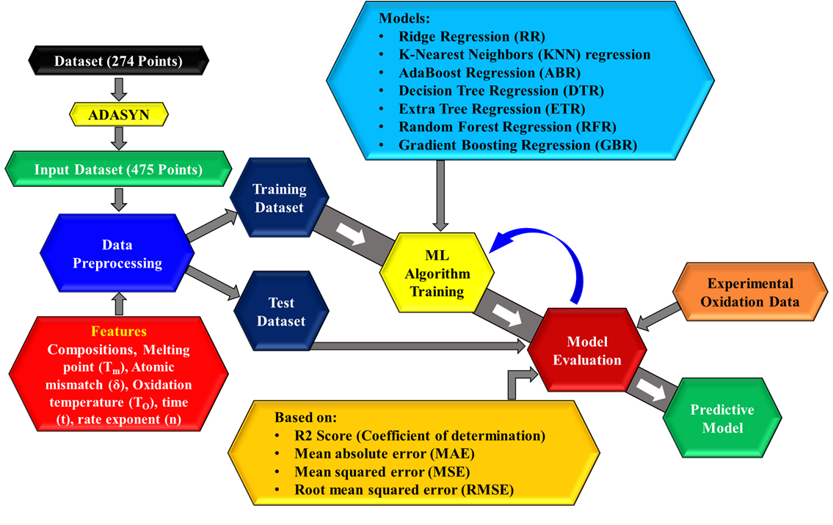

Figure 1. A modified machine learning approach for prediction of oxidation rate. constants in RHEAs.

Construction of input dataset
The first step of the Machine Learning method is to gather raw data from different sources that are relevant to the problem. The resulting initial dataset, obtained by performing an exhaustive literature survey, encompasses a total of 108 oxidation rate constant (k) values, with each data point associated with a specific time interval. To enhance the granularity of the dataset, each time interval was partitioned into three distinct segments: the starting time, intermediate time, and ending time. This partitioning process generated three data points for each instance within the dataset, expanding the total number of data points to 274. The process of building this input dataset is expressed in Fig. 2. It is important to note that while the time divisions were introduced, the remaining features in the input dataset and the target feature (k) remained unchanged. Thus, the division based on time intervals provided a more detailed representation of the data points while preserving the integrity of the other features.

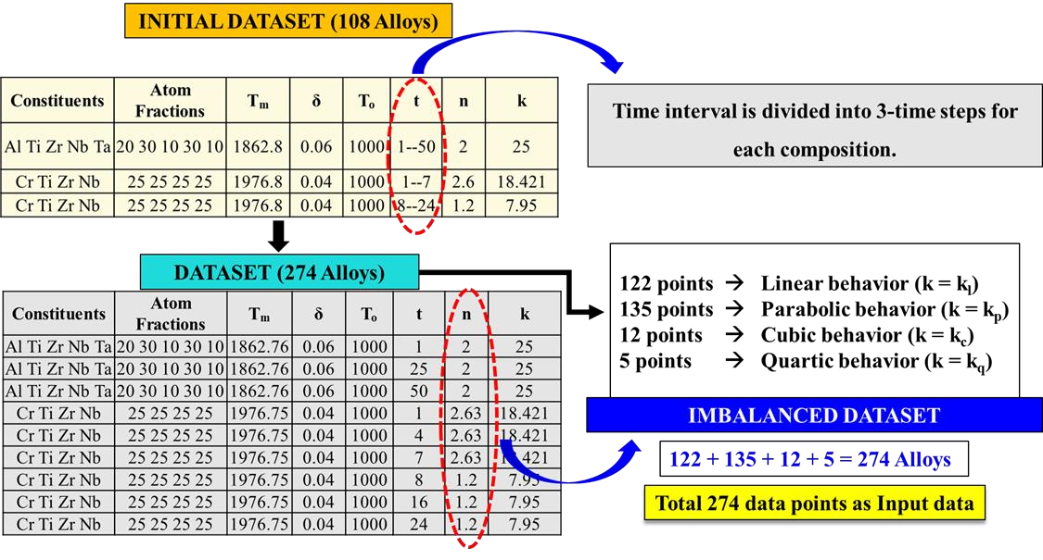

Figure 2. Construction of Dataset

Construction of feature pool
From the detailed literature survey, it has been inferred that the oxidation process in an alloy is subject to the influence of multiple factors. These factors include the alloy's chemistry, along with their corresponding thermodynamic and kinetic parameters [15, 16]. These parameters hold prominent significance as fundamental input features for ML models, for oxidation behavior. Specifically, the feature pool included the atomic percentage of each of the elements (Ti, V, Cr, Zr, Nb, Mo, Hf, Ta, W, Al, Si) within the alloy, the melting point of the alloy (T_{m}) [17], the atomic size difference (δ) [18], as well as the oxidation temperature(T_{o}), oxidation time (t), and the oxidation rate constant (n). The numerical values associated with these input features were determined by employing the following relationships for each instance:
𝑇_{𝑚} 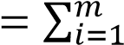 𝑐_{𝑖}𝑇_{𝑖}, (2)

𝛿 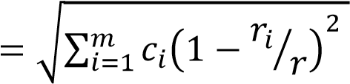̅ , (3)
Here, T_{i} and r_{i} represent the melting point, and atomic radius of the i^{th} element respectively (both are elemental properties), c_{i} denotes the atomic concentration of the i^{th} element (it is the atomic percentage of the i^{th} element in the alloy). 𝑟̅ refers to the average atomic radius of all
the ‘m’ elements in the alloy and it can be calculated as 𝑟̅ 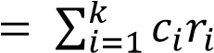. The oxidation temperature (T_{o}) refers to the specific temperature at which the alloy is presumed to be oxidized in an oxidizing environment. Similarly, oxidation time (t) represents the duration of oxidation. The oxidation rate exponent (n) is determined from oxidation experiments, that describe the temperature dependence of the oxidation rate for a certain alloy system [6].

Results & discussion

Data analysis and imbalance handling
The dataset used to develop the current machine-learning model consists of several input features. The feature set appears to be mixed in nature, consisting of both the categorical and continuous features. In this case, the categorical feature is the oxidation rate exponent (n), which captures different types of oxidation rates. Based on the n-values, a clear difference can be observed within the dataset as shown in Fig. 3a.

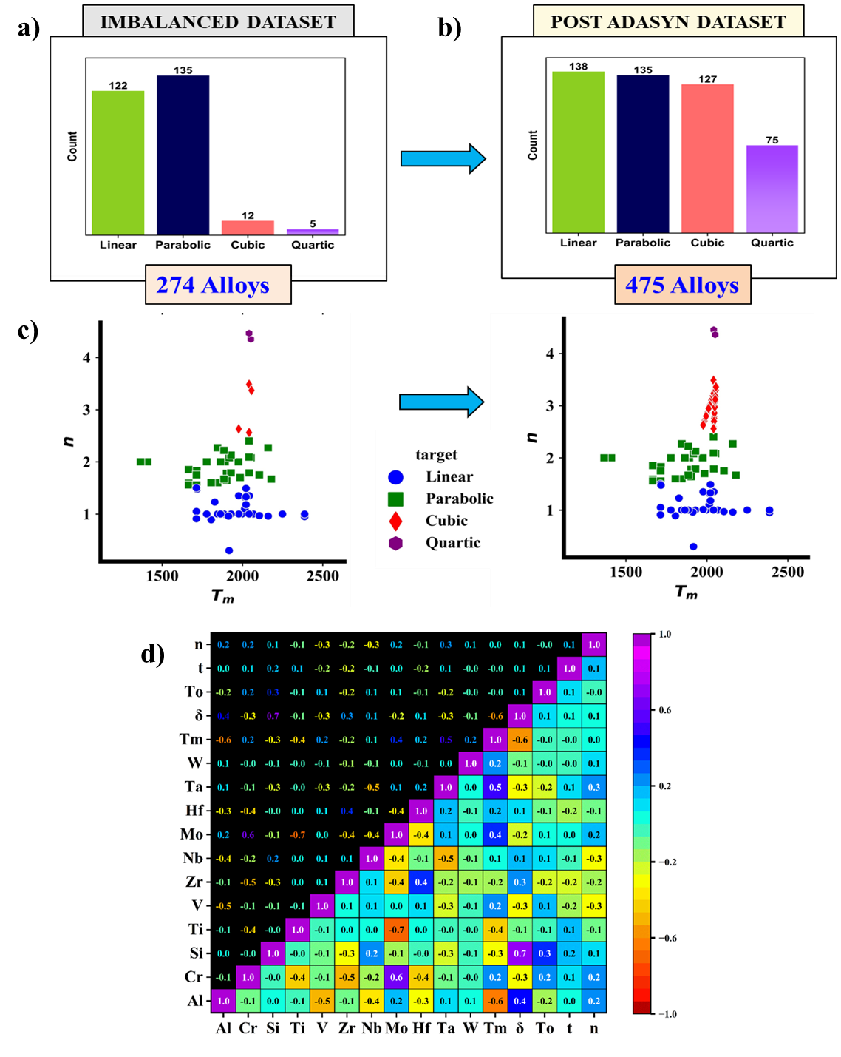

Figure 3. Distribution of dataset based on oxidation rate exponent: (a) Initial dataset, (b) Dataset post-ADASYN; (c) Comparative study showing the accommodation of the minority classes (here cubic and quartic) in the regions where the majority classes are clustered; (d) Correlation matrix computed using Pearson's correlation coefficient across all the input variables.
Out of 274 alloys, 122 were found to follow linear law behavior, 135 exhibited parabolic law behavior, 12 followed cubic law behavior, and the remaining 5 demonstrated quartic law behavior. These laws were observed at various temperature ranges, unveiling the complex dynamics of oxidation in different alloy compositions. The bar chart depicted in Fig. 3a reveals that the input dataset has a clear class imbalance, with varying compositions distributed unevenly across different categories. An imbalanced dataset can hinder the positive development of the machine learning models. The imbalance in the data can cause the machine learning model to show a bias toward the oxidation rate exponent (n) values (which is in this case) of the majority class and can reduce the overall performance of the model. The issue can be tackled by utilizing oversampling techniques, specifically the Adaptive Synthetic (ADASYN) Oversampling technique [19]. The purpose of oversampling is to deal with class imbalance by increasing the representation of the minority classes, such as the Cubic and Quartic classes in this particular scenario. This helps to mitigate the biasness that can rise from class imbalance. The ADASYN algorithm was first put forward by He et al. to reduce bias and facilitate adaptive learning in the backdrop of imbalanced datasets [20]. The key idea behind ADASYN is to use a density distribution as a criterion for generating synthetic samples. Density refers to the number of neighboring instances in a given region of the feature space. The ADASYN technique considers instances belonging to the minority class and having fewer neighbors as being harder to learn. A synthetic data point, denoted as 𝑠_{𝑖}, is formed by combining a data point in the minority class 𝑥_{𝑖} and randomly selecting one of the K nearest neighbours for 𝑥_{𝑖}, denoted as 𝑥_{𝑧𝑖} and using a linear combination it can be computed using Eq. (4).
𝑠_{𝑖} = 𝑥_{𝑖} + (𝑥_{𝑧𝑖} − 𝑥_{𝑖}) × 𝜆 (4) Here λ is an arbitrary integer that lies between [0, 1].
The dataset, which consisted of 274 alloys, effectively achieved a balanced distribution across the various alloy groups once the ADASYN approach was used. Fig. 3b illustrates the bar chart analysis made on the post-ADASYN dataset. The improved proportions for the linear, parabolic, cubic, and quartic categories as 138:135:127:75, respectively. The ADASYN method made it possible to expand the dataset, producing a total of 475 alloys that included both the original data points and the synthetically produced data points, and this post-ADASYN dataset is utilized by both models that predict n and k values. By leaving out the data points that exhibit a parabolic nature, ADASYN adaptively augmented the dataset by generating additional data points in the vicinity of the linear, cubic, and quartic nature data points. In Fig. 3c, the scatter plot visualizes the variations between the pre-ADASYN dataset and the post-ADASYN dataset in the n vs. T_{m} space. The Pearson correlation coefficient matrix of the 475 alloys dataset shown in Fig. 3d reveals that there are no input features in the dataset that possess correlation values that are close to 1 or -1, indicating the absence of strong positive or negative correlations.

Model development for oxidation rate exponent (n)
As per the authors knowledge, so far there has been no evidence of the utilization of machine learning techniques in research attempts aimed at predicting the oxidation rate exponent (n) of various metals and alloys. This resulted in the implementation of a new approach involving predictive machine learning techniques for comprehending oxidation kinetics prior to investigating oxidation behavior. An ML model was built using the post-Adasyn dataset as the input dataset, which consisted of 475 data points with 15 predictors (T_{m}, δ, T_{o}, t, and compositions of Ti, V, Cr, Zr, Nb, Mo, Hf, Ta, W, Al, Si). Initially the input dataset was split into two separate subsets: a training set containing 318 (67%) data points and a testing set containing 157 (33%) data points. This division allows for training the model on a substantial portion of the data while reserving a separate set for evaluation. Evaluating the model on unseen data from the testing set helps to provide a more reliable assessment of its generalization performance. Upon examination of the given dataset, it becomes evident that the various features lack uniformity in their scales. If a comparison is made between values from different features, those with higher magnitudes (like melting point here) would exert a dominant influence over lower values (like atomic size difference), potentially leading to erroneous outcomes. To counteract this situation, feature scaling is applied. In this case, both the training and testing sets, along with their corresponding features, undergo standardization using the "StandardScaler" method. The standard scaler is calculated from Eq. (5):
𝑧_{𝑖} = (𝑥_{𝑖} − 𝜇)⁄𝑠 (5)
Where 𝑧_{𝑖}, 𝑥_{𝑖} represents the standardized value and original value of the feature in the instance (i) respectively, 𝜇, 𝑠 denotes the mean (average) value and the standard deviation of the feature calculated from the training set respectively. This method scales the features in a manner such that each feature attains a mean of 0 and a standard deviation of 1. Through this normalization process, all features are brought to a comparable scale, enabling accurate and reliable model training and evaluation. An Extra Tree Regressor (ET Regressor) model was constructed to estimate the oxidation rate exponent (n). This estimation was based on a feature space consisting of 15 predictors. The accuracy of the model was evaluated using the grid search cross-validation technique, with a parameter value of cv = 5 (no. of folds).
This involved randomly partitioning the training set into five smaller sets, known as folds. The model was then trained on four folds while validating the remaining one-fold. The entire process was repeated five times, resulting in 25 different sets used for estimating the model's efficiency. To determine the best parameters for the Extra Tree Regressor (ETR), a grid search was employed. This involved exploring various combinations of parameters such as n_estimators, criterion, max_depth, min_samples_split, min_samples_leaf, min_weight_fraction_leaf, max_features, max_leaf_nodes, bootstrap, and max_samples. The accuracy metrices and their comparison is provided in Fig. 4a and Fig. 4b. The grid search process-built models for each parameter combination and identified the best parameters. The best parameters of the ETR model are provided in Table 1. Using the best parameters, the evaluation yielded an average cross-validation accuracy, measured by the R-squared value, of 92.53% which can be seen from Fig. 4b. To assess the Extra Tree Regressor's predictive ability for the rate exponent (n) values in the dataset, a testing dataset of 157 points was utilized. The testing dataset achieved an impressive R-squared value of 96.61%, accompanied by a low MAE of 0.099 and MSE of 0.044, demonstrating excellent performance. A scatter plot of predicted values versus actual values was employed to visualize the alignment between the model's predictions and the actual values. A well-fitted regression model would exhibit predicted values closely clustered around the diagonal line, indicating accurate predictions. In this study, the majority of predicted n values for the testing set were found to be closely scattered around the fitted line depicted in Fig. 4c, suggesting the model's good predictability for the given dataset.
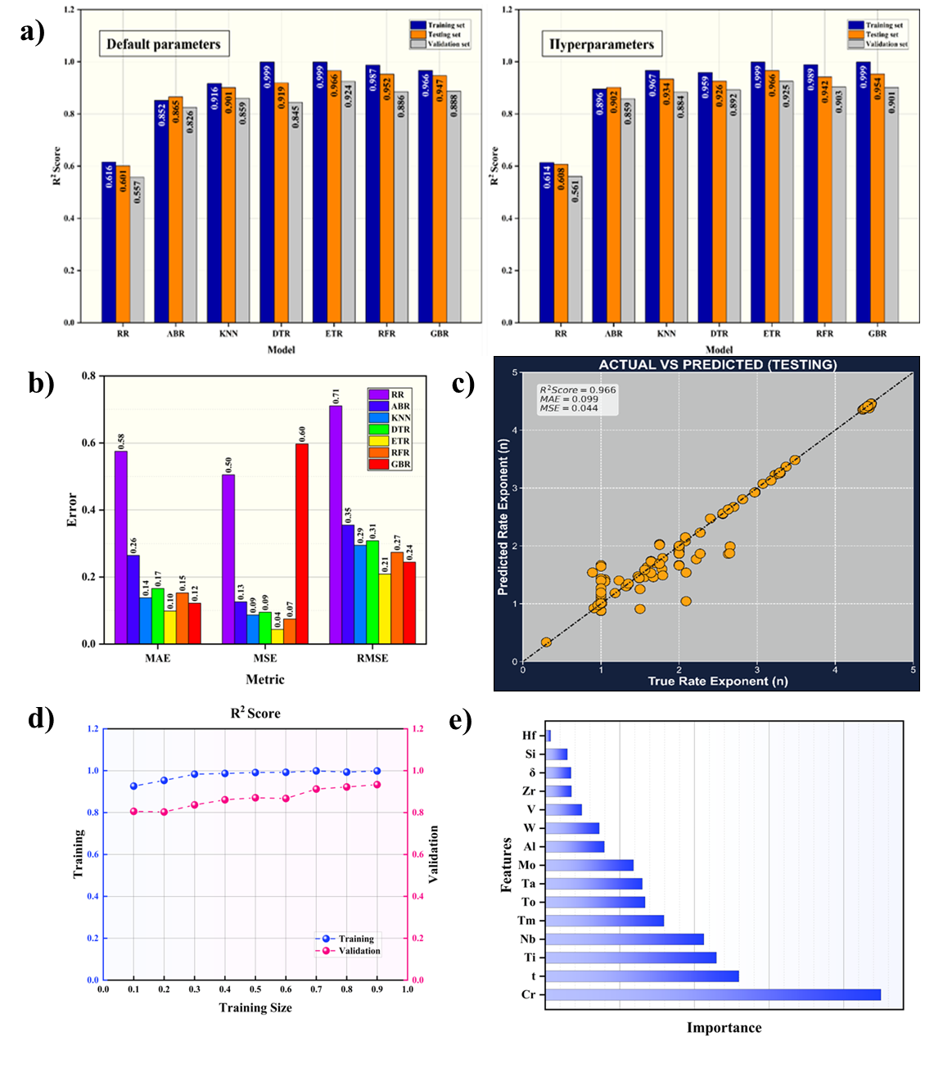
Figure 4. For n-values prediction (a) R2 scores between various models trained with default parameters (left) and hyperparameters (right). (b) MAE, MSE, and RMSE values across various models, (c) Predicted versus actual n-values, (d) Learning Curve, (e) Feature importance.
Table 1 ET Regressor parameters, their search space and best parameters.
Model | Parameter | Search Space | Best Parameter
Extra Trees Regressor (ET  Regressor) | n_estimators | [10, 30, 50, 70,  100] | 100
Extra Trees Regressor (ET  Regressor) | criterion | [‘mae’, 'mse’, ‘friedman_mse’,  ‘poisson’] | ‘poisson’
Extra Trees Regressor (ET  Regressor) | max_depth | [None, 40, 50, 60,  70, 80, 90, 100] | None
Extra Trees Regressor (ET  Regressor) | min_samples_split | [2, 3, 4, 5] | 2
Extra Trees Regressor (ET  Regressor) | min_samples_leaf | [1, 2, 3, 4, 5] | 1
Extra Trees Regressor (ET  Regressor) | min_weight_fracti on_leaf | [0, 0.001, 0.01,  0.1] | 0
Extra Trees Regressor (ET  Regressor) | max_features | [1, ‘sqrt’, ‘log2’,  None] | None
Extra Trees Regressor (ET  Regressor) | max_leaf_nodes | [None, 70, 80, 90,  100, 120] | None
Extra Trees Regressor (ET  Regressor) | bootstrap | [True, False] | False
Extra Trees Regressor (ET  Regressor) | max_samples | [0.1, 0.5, 1.0,  None] | None

Furthermore, a learning curve was examined and illustrated in Fig. 4d to understand the relationship between the training dataset size and the model's performance. Learning curves depict the training and validation (or testing) errors as a function of the training dataset size. It provides insights into whether the model is underfitting or overfitting. In this case, the learning curve showed that the training scores consistently exceeded the cross-validation scores, which is a common trend in ML modeling. Initially, there was a significant gap between the training and cross-validation scores, indicating higher variance. However, as the dataset size increased, the cross-validation score improved while the training score exhibited a slight increase before reaching a plateau. The decreasing gap between the two curves indicated lower variance, suggesting that the model was not overfitted. The performance of the Extra Trees Regressor was compared with multiple models including K-nearest Neighbors (KNN) regression, Ridge Regression (RR), AdaBoost Regression (ABR), Decision Tree Regression (DTR), Random Forest Regression (RFR), Gradient Boosting Regression (GBR) by training with both default parameters and hyperparameters obtained through grid search cross-validation. Two bar charts are provided in Fig. 4a, presenting the R-squared scores achieved on the training, testing, and validation datasets across all the models trained with default parameters and hyperparameters. The Extra Trees Regressor emerged as the top performing model among the various machine learning algorithms, exhibiting superior R-squared scores when default parameters were employed. Interestingly, even after hyperparameter tuning, the Extra Trees Regressor continued to demonstrate its efficacy as the most optimal model for the regression problem at hand. Additionally, when comparing evaluation metrics such as mean absolute error (MAE), mean squared error (MSE), and root mean squared error (RMSE) on the testing dataset, the Extra Tree Regressor outperformed the other algorithms, which can be seen in Fig. 4b. With the help of GridSearchCV and the ET regressor, feature importance was obtained and represented in Fig. 4e. Excitingly, the analysis unveiled a hierarchy of feature importance, with chromium (Cr) taking the lead, followed closely by time (t). These findings have substantial implications for refractory high-entropy alloys (RHEAs), as the prominence of chromium suggests its pivotal role in enhancing the oxidation properties of these advanced materials. Interestingly, literature reports support this observation, further validating the influence of chromium-rich RHEAs on oxidation behaviour [18]. Delving deeper into the non-compositional features, time (t) emerges as a key driver, revealing its crucial role in unravelling the complexities of the oxidation mechanism. Similarly, the oxidation temperature (T_{o}) is a critical thermodynamic parameter that governs the complexities of the oxidation process. Lattice strains arising from size variations among the constituent elements find representation in the parameter δ, further contributing to the overall oxidation behavior. Additionally, the melting point (T_{m}) reveals itself as a weighted average thermodynamic property, shaping the oxidation landscape of the materials under investigation. It's worth highlighting that the order of feature importance may exhibit nuances in response to changes in the dataset or the specific context of analysis. However, these insights reinforce the notion that a delicate interplay between thermodynamic and kinetic properties profoundly impacts the oxidation rate exponent, aligning as in good agreement with the existing scientific literature. In conclusion, this exploration of feature importance within the ET regressor model provides a captivating glimpse into the underlying dynamics governing oxidation behavior. The prominence of chromium and titanium-rich RHEAs, coupled with the vital roles played by time, oxidation temperature, lattice strains, and melting point, showcases the intricate dependence of factors influencing the oxidation rate exponent.

Model development for oxidation rate constant (k)
In the next step, the post-ADASYN dataset containing 475 data points and 15 independent features along with the rate exponent (n) was divided into a training set of 318 points and a testing set of 157 points (67% for training and 33% for testing). The accuracy of the regression-based ML model, namely the Random Forest regressor (RFR), was assessed by utilizing the training dataset comprising 318 points. Grid search was further employed to determine the optimal values of the parameters specific to the Random Forest Regressor in this study. By constructing models for various combinations of these parameters, the best parameter values were identified based on their performance. The best parameters of the ETR model are provided in Table 2. The accuracy metrices are provided in Fig. 5a and Fig. 5b. The effectiveness of the Random Forest Regressor was evaluated based on the average cross validation accuracy, represented by the R-squared value. The best parameters yielded an average cross-validation accuracy of 99.19%. To assess the predictive capability of the Random Forest Regressor for the rate constant (k) values in the dataset, a separate testing dataset containing 157 points was used. The testing dataset achieved an R-squared value of 98.85%, indicating satisfactory predictive performance. Furthermore, the scatter plot displayed in Fig. 5c depicted the predicted 'k' values for the testing set against the corresponding actual 'k' values, with a fitted line. The plot revealed that a significant portion of the predicted 'k' values for the testing set were closely clustered around the fitted line. This observation suggests that the model demonstrates strong predictive ability for the specific dataset, as it accurately predicts the 'k' values in relation to the actual values. Analysis of the learning curves, which is manifested in Fig. 5d demonstrated the standard trend in ML, where the training scores consistently exceeded the cross-validation scores. Initially, a notable gap between the training and cross-validation scores indicated higher variance. However, as the dataset size increased, this gap diminished, indicating reduced variance and a well-fitted model without overfitting concerns. To compare the performance of the Random Forest regressor, other models including K-nearest Neighbours (KNN) regression, Ridge Regression
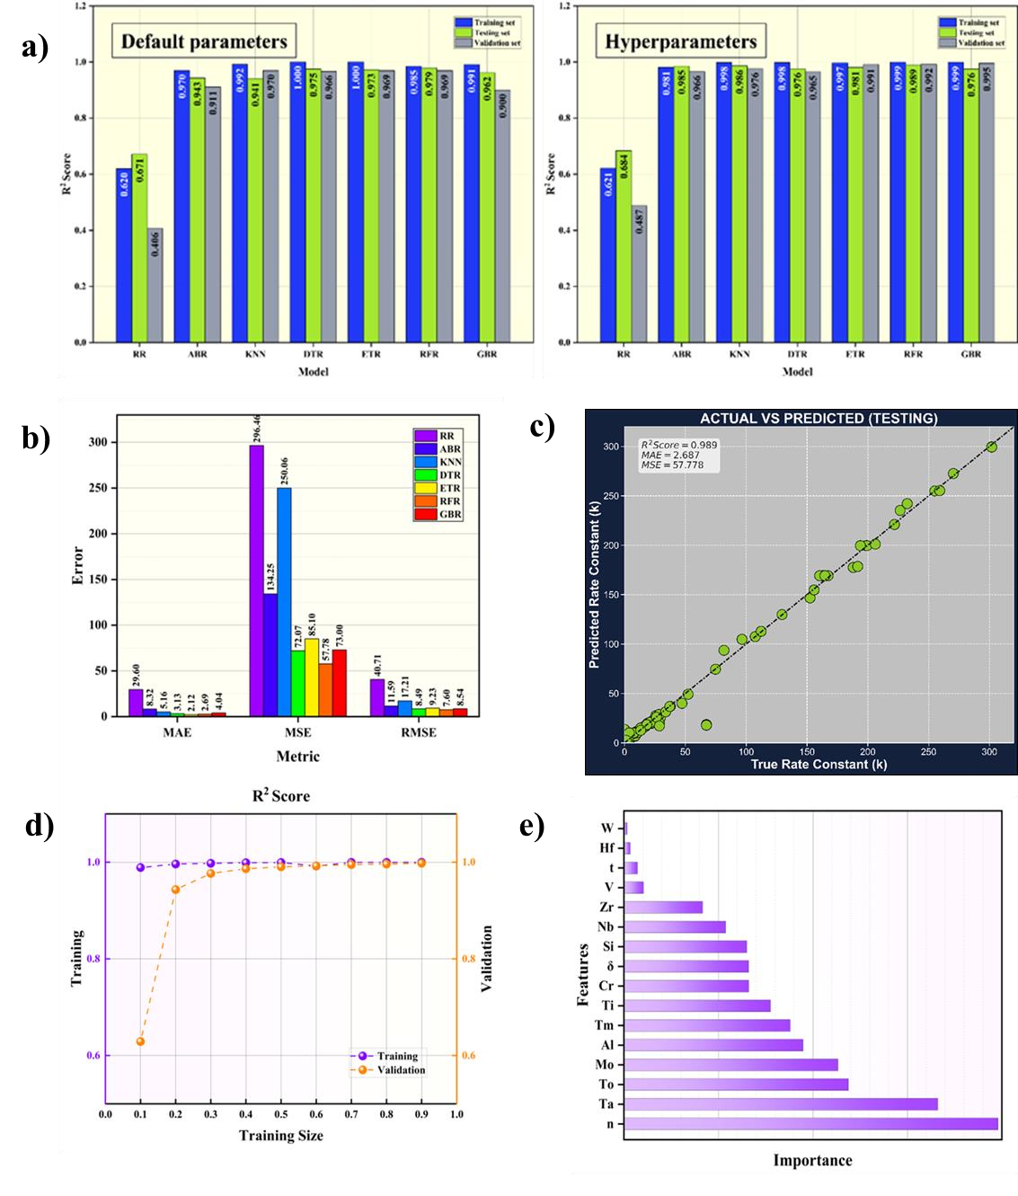
(RR), Decision Tree Regression (DTR), Extra Trees Regression (ETR), AdaBoost Regression (ABR), Gradient Boosting Regression (GBR) were trained with and without hyperparameter tuning using the input training data. The performance of these models was compared with the Random Forest regressor using both default parameters and hyperparameters obtained through grid search cross-validation. A bar plot was generated in Fig. 5a, presenting the R-squared scores for training, testing, and validation datasets across all the models. Among all the ML algorithms, the Random Forest Regressor demonstrated superior performance in terms of training, testing, and cross-validation R-squared scores, when default parameters were used. Notably, even after hyperparameter tuning, the Random Forest Regressor remained the most effective model for the regression problem at hand. Additionally, a bar plot shown in Fig. 5b provides a comparison of evaluation metrics such as mean absolute error (MAE), mean squared error (MSE), and root mean squared error (RMSE) on the testing dataset indicated that the Random Forest regressor outperformed (with MAE = 2.69, MSE = 57.78, RMSE = 7.60) other algorithms in all metrics.

Figure 5. For k-values prediction (a) R2 scores between various models trained with default parameters (left) and hyperparameters (right). (b) MAE, MSE, and RMSE values across various models, (c) Predicted versus actual k-values, (d) Learning Curve, (e) Feature
Importance.
Table 2 Random Forest Regressor parameters, their search space and best parameters.
Model | Parameter | Search Space | Best Parameter
Random Forest  Regressor (RFR) | n_estimators | [10, 20, 40, 60, 80,  100] | 80
Random Forest  Regressor (RFR) | criterion | [‘mae’, 'mse’, ‘friedman_mse’,  ‘poisson’] | ‘mse’
Random Forest  Regressor (RFR) | max_depth | [None, 40, 50, 60,  70, 80, 90, 100] | None
Random Forest  Regressor (RFR) | min_samples_split | [2, 3, 4, 5] | 2
Random Forest  Regressor (RFR) | min_samples_leaf | [1, 2, 3, 4, 5] | 1
Random Forest  Regressor (RFR) | min_weight_fracti on_leaf | [0, 0.001, 0.01,  0.1] | 0
Random Forest  Regressor (RFR) | max_features | [1, ‘sqrt’, ‘log2’,  None] | None
Random Forest  Regressor (RFR) | max_leaf_nodes | [None, 70, 80, 90,  100, 120] | None
Random Forest  Regressor (RFR) | bootstrap | [True, False] | True
Random Forest  Regressor (RFR) | max_samples | [0.2, 0.4, 0.6, 0.8,  1.0] | 0.4

This conclusion highlights the model's efficient prediction of oxidation rate constant (k) values and its robustness as a platform for predicting new compositions. In summary, the obtained results indicate the superior performance of the Random Forest regressor in predicting oxidation rate constant (k). After conducting model validation for the Random Forest regressor, an intriguing analysis of feature importance was performed and manifested in Fig. 5e to assess the significance of the selected features in predicting the oxidation rate constant (k). Utilizing GridSearchCV in conjunction with the Random Forest regressor, a visually captivating feature importance figure was generated, unravelling comprehensively the relative importance of each feature. The analysis revealed a fascinating hierarchy of feature importance, with the oxidation rate exponent (n) taking precedence as the most influential factor in determining the oxidation mechanism. This finding concurs with well-established literature reports, providing further confirmation of the crucial role played by the oxidation rate exponent in understanding oxidation behavior. In addition to the oxidation rate exponent, several other noteworthy features emerged as significant determinants of the oxidation process. The oxidation temperature (T_{o}) surfaced as a pivotal thermodynamic parameter, wielding considerable influence over the oxidation behavior. Similarly, the dimension of time (t) assumed a critical role, encapsulating the kinetic properties associated with the constituent elements and yielding valuable insights into the underlying oxidation mechanism. This observation suggests that the incorporation of chromium in RHEAs enhances their oxidation properties, a trend corroborated by prior literature findings. Moreover, the parameter δ effectively captured the lattice strains resulting from size variations among the constituent elements, further contributing to the overall oxidation behavior. Additionally, the melting point (T_{m}) surfaced as a significant weighted average thermodynamic property, exerting its influence on the oxidation characteristics of the materials under investigation. It is crucial to acknowledge that the order of feature importance may exhibit variations in response to changes in the dataset or the specific context of the analysis. Nevertheless, these fascinating findings align harmoniously with existing research, reaffirming the influential impact of both thermodynamic and kinetic properties on the prediction of the oxidation rate constant. In conclusion, this feature importance study within the Random Forest regressor model provides valuable insights into the underlying factors governing the oxidation rate constant. The prominence of the oxidation rate exponent, complemented by the roles played by oxidation temperature, time, chromium, lattice strains, and melting point, underscores the intricate interplay between thermodynamic and kinetic properties in accurately predicting the oxidation rate constant. These findings contribute to the broader understanding of oxidation mechanisms and pave the way for further advancements in material design and development.

Experimental validation for the ML models
To understand the extent of reliability of the ML model, experimental validation was conducted on five different alloy systems. The RHEAs were selected by employing the Thermo-Calc software in conjunction with the TC-HEA3 database through examination of the temperature-dependent phase transitions in various quaternary and quinary equiatomic RHEAs [21]. To select proper RHEA compositions, all the quaternary and quinary compositions of 11 elements containing Al or Si or both were searched through the CALPHAD database in order to find out whether they form single-phase or not. The Thermo-Calc calculations of the prospective phases were made from 300 to 3000 K temperature and at 1 atm pressure. Thorough analysis of the property diagrams of few particular RHEA alloys namely AlTiVMo, AlCrTiMo, AlTiNbMo, AlTiZrNb, and AlTiVMoNb, determined using CALPHAD method revealed that the selected compositions exhibit the formation of a BCC_B2 single-phase solid solution below 2100 K, and remained stable down to approximately 300 K. The property diagrams are represented in Figure S1 (Supplementary Information I). To synthesize the alloy compositions, proportional amount of the corresponding elements was weighed and melted into a 5-gram button using an electric arc furnace. These as-cast buttons were sealed within a quartz ampoule separately under an argon atmosphere and subsequently subjected to a 48-hour heat treatment at 1273 K and followed by a quenching process to obtain the single phase microstructure. Subsequently, the oxidation behavior of these alloys was evaluated to validate the outcomes derived from machine learning algorithms.
The phase assemblage study of the homogenized alloys was evaluated using X-Ray Diffraction (XRD) analysis at a scan rate of 1°/min and is displayed in Fig. 6. The XRD patterns reveal majority of the homogenized compositions primarily exhibit a BCC_B2 solid solution phase. However, small diffraction peaks corresponding to intermetallic phases of Al₅Mo, Al₈Mo₃, Al₃Nb in AlTiCrMo. Surprisingly, the XRD pattern of the homogenized AlTiNbMo composition revealed to be containing intermetallic composition of Al₂Nb₃Mo₃ as a major phase along with few peaks corresponding to AlNbTi₂.The precise lattice parameters of the equiatomic RHEAs were estimated using the Nelson-Reilly method and the calculated values are provided in the Table 3. The lattice parameter of the AlTiNbMo has not been calculated as the desired phase composition has not been achieved. Considering the outcome, it would be safer to assume that among the selected five compositions, the former three compositions yielded completely single phase, whereas the latter two formed multi-phase. For further clarification, microstructural investigation was also carried out in the backscattered electron (BSE) imaging mode using Scanning Electron Microscopy (SEM).
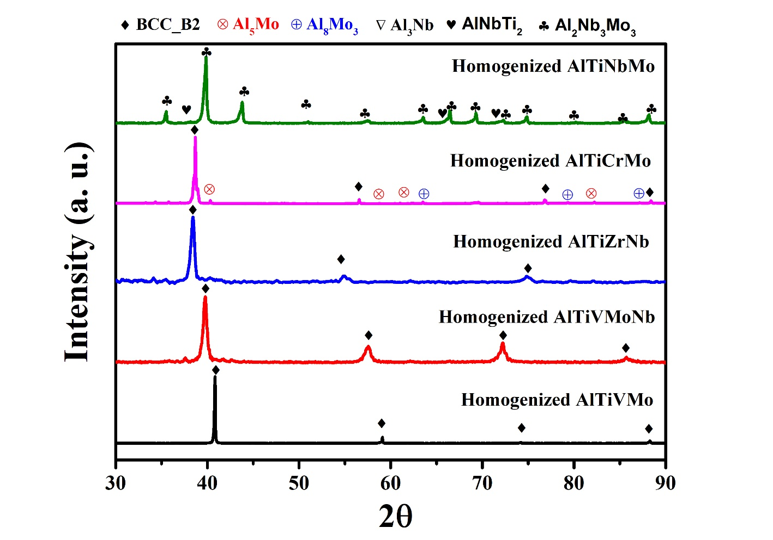
Figure 6. XRD patterns of the homogenized alloys.
Table 3: Precise lattice parameters for the fabricated RHEAs.
Composition | a (nm) | b (nm) | c (nm)
AlTiVMo | 0.3131 | 0.3131 | 0.3131
AlTiVMoNb | 0.3199 | 0.3199 | 0.3199
AlTiZrNb | 0.2334 | 0.2334 | 0.2334
AlTiCrMo | 0.3085 | 0.3085 | 0.3085

Fig. 7 displays the BSE-SEM images of the homogenized AlTiVMo, AlCrTiMo, AlTiNbMo, AlTiZrNb, and AlTiVMoNb RHEA samples. Corresponding EDS-Elemental maps are also shown in Figure S6 (Supplementary Information I). The BSE microstructures corresponding to the first three alloys show only single-phase contrast. No other phase contrast can be observed in the microstructures. Occasional distribution of pores (black spots in the microstructure) can also be seen in the micrographs. On the other hand, from the Fig. 7d evenly distributed second phase precipitates are clearly visible in the microstructure of AlTiCrMo. On the other hand, the BSE-SEM microstructure of AlTiNbMo shows a clear dual phase microstructure with two phase contrast. A magnified image is provided in Figure S7 (Supplementary Information I). The phase with the light grey contrast shows homogenous distribution of Al, Nb and Mo, whereas occasional clustering of Ti-rich region is observed in the phase with dark grey contrast.
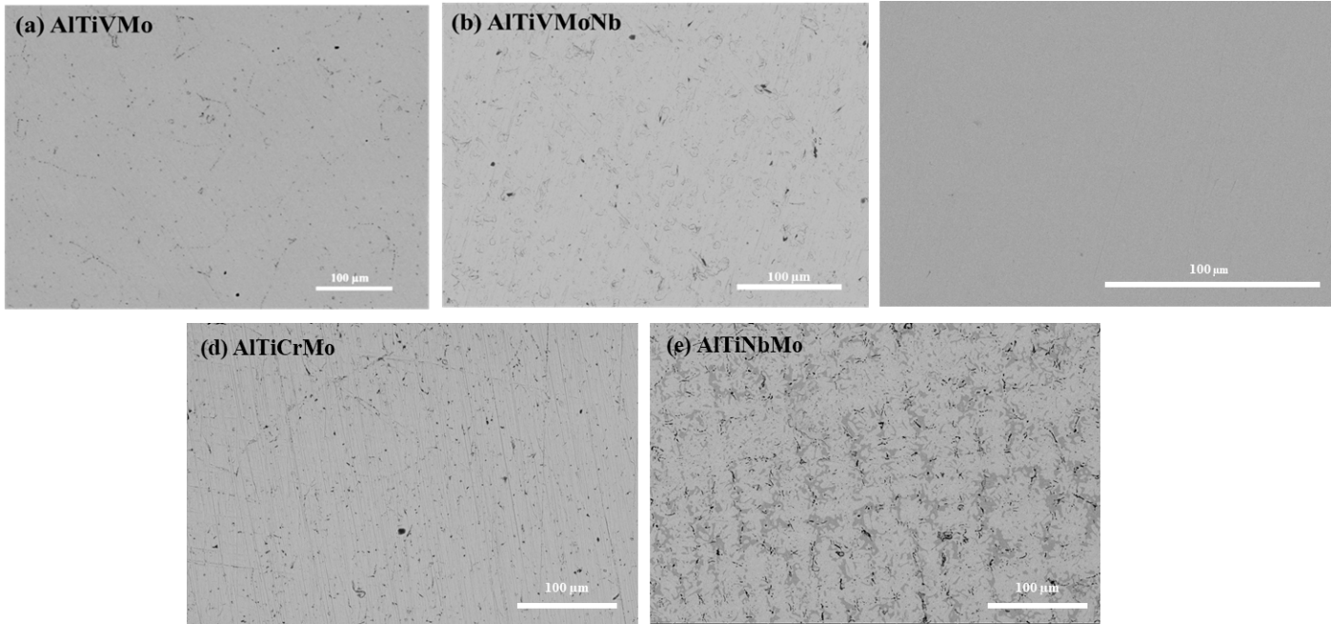

Figure 7. BSE-SEM micrographs of the homogenized samples (a). AlTiVMo (b)
AlTiVMoNb (c) AlTiZrNb (d) AlTiCrMo (e) AlTiNbMo.
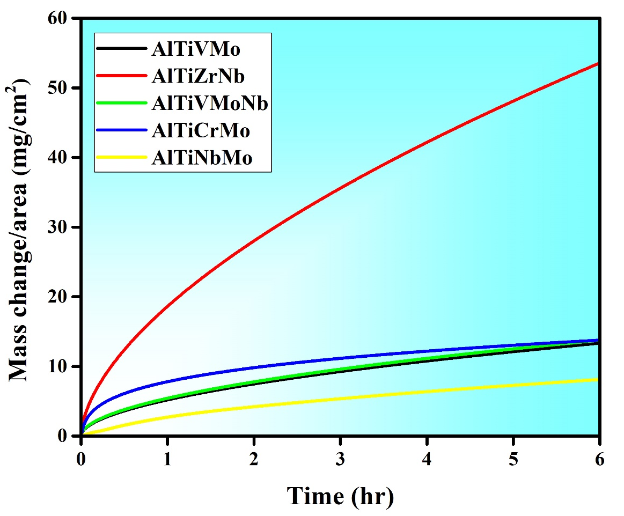
Isothermal oxidation tests were conducted within a thermogravimetric system (STA 2500 Regulus). Isothermal oxidation of AlTiVMo, AlCrTiMo, AlTiNbMo, AlTiZrNb, and AlTiVMoNb alloys was carried out for 6h in the temperature regime of 1300°C. The sample was heated from room temperature in a TGA furnace at a heating rate of 20K/min in an N₂ atmosphere at a purge flow rate of 80 ml/min and upon reaching the final temperature a dwell time of 6h had been implied at an N₂ flow rate of 20 ml/min. The mass change of the samples was measured as a function of exposure time by an electronic balance technique with an accuracy of 0.02 mg. After the test, the sample was furnace cooled to room temperature. The mass gain curve for the RHEA was plotted concerning the time and provided in Fig. 8. The mass gain curve depicts a parabolic pathway of oxidation with increasing time for almost all the samples. The parabolic path seems to follow a two-stage rate law; a fast initial stage followed by a steady state.

Figure 8. Mass-gain versus the exposure time curves for RHEA compositions.
From the graphs it can be seen that except the AlTiZrNb composition, all the RHEAs start to reach a plateau at the end of the oxidation cycle. The achievement of the steady state can be due to the passivation of the formed oxide layer on the surface which is providing resistance to penetration of oxygen from the surface to the bulk. From the graphs it can be seen that upon increasing the element number the oxidation resistance does not increase much, implementing the quaternary composition has better oxidation resistance. However, in case of the equiatomic AlTiZrNb alloy, the addition of Zr seems to have a detrimental effect on the mass gain. As the oxides of the Zr has higher atomic mass, this may increase the overall mass gain during the oxidation of the alloy. Further, the oxidation rate law (provided in the equation below) is used to calculate the oxidation kinetics for both alloys.
(∆𝑚)𝑛 = 𝑘𝑡
𝐴
where Δm is the mass gain, A is the unit surface area of the specimen, k is the oxidation rate constant, and t is the oxidation time. Following the oxidation process, the accuracy of the ML model’s predictions is assessed by comparing its estimated oxidation rate exponent (n) and rate constant (k) values with the TGA experimental values and the comparison between them is tabulated in and this comparison is tabulated in Table 4. This enables the evaluation of how well the ML model generalizes to new alloys and whether their oxidation behavior can be accurately predicted.
Table 4: Comparison of ML predicted and experimental n, k values.
RHEA | n  (predicted) | n  (experimental) | k  (predicted) | k  (experimental)
AlTiVMo | 1.59 | 1.9 | 11.77 | 23.10
AlTiZrNb | 1.81 | 1.70 | 40.06 | 142.07
AlTiVMoNb | 1.3 | 1.93 | 15.55 | 26.15
AlTiCrMo | 2.052 | 1.78 | 9.545 | 73.89
AlTiNbMo | 1.693 | 1.61 | 11.323 | 4.63

Conclusion
In this study, the primary objective was to develop accurate machine-learning models capable of predicting the oxidation rate exponent (n) and oxidation rate constant (k) values for RHEAs along with its experimental validation. Two regression-based supervised learning algorithms, namely the Extra Trees regressor and Random Forest regressor, were implemented using a dataset consisting of 475 data points. For the prediction of the oxidation rate exponent (n), the Extra Trees regressor achieved an impressive average cross-validation R-squared score of 92.53% and a testing R-squared score of 96.61%. Similarly, the Random Forest regressor yielded remarkable results, with an average cross-validation R-squared score of 99.19% and a testing R-squared score of 98.85% for predicting the oxidation rate constant (k). Further, the learning curve implies that the models are capable of generalizing well to unseen data, ensuring their reliability and applicability beyond the training dataset. In addition, the experimental evaluation of oxidation rate exponent revealed to be akin towards the predicted one, however the differences in the values of oxidation rate constant can be observed. These findings highlight that the developed machine learning models exhibit exceptional performance in predicting the oxidation rate exponent and oxidation rate constant for RHEAs which can help in understanding their oxidation behaviour.
Data and Code Availability Statement
The codes are publicly available on Supplementary Information-II.

Declaration of Competing Interest
The authors declare that they have no known competing financial interests or personal relationships.

Acknowledgment
We would like to acknowledge the Department of Science and Technology (DST), Science and Engineering Research Board (SERB), and Indian Institute of Technology Kanpur, India, for supporting us in conducting this study.

References:
[1] O. Senkov, G. Wilks, D. Miracle, C. Chuang, P. Liaw, Refractory high-entropy alloys, Intermetallics 18(9) (2010) 1758-1765.
[2] O.N. Senkov, G. Wilks, J. Scott, D.B. Miracle, Mechanical properties of Nb25Mo25Ta25W25 and V20Nb20Mo20Ta20W20 refractory high entropy alloys, Intermetallics 19(5) (2011) 698-706.
[3] O.N. Senkov, D.B. Miracle, K.J. Chaput, J.-P. Couzinie, Development and exploration of refractory high entropy alloys—A review, Journal of materials research 33(19) (2018) 3092-3128.
[4] K.-C. Lo, H. Murakami, J.-W. Yeh, A.-C. Yeh, Oxidation behaviour of a novel refractory high entropy alloy at elevated temperatures, Intermetallics 119 (2020) 106711.
[5] K. Kawagishi, A.-C. Yeh, T. Yokokawa, T. Kobayashi, Y. Koizumi, H. Harada, Development of an oxidation-resistant high-strength sixth-generation single-crystal superalloy TMS-238, Superalloys 9 (2012) 189-195.
[6] B. Gorr, S. Schellert, F. Müller, H.-J. Christ, A. Kauffmann, M. Heilmaier, Current status of research on the oxidation behavior of refractory high entropy alloys, Advanced Engineering Materials 23(5) (2021) 2001047.
[7] O. Senkov, S. Senkova, D. Dimiduk, C. Woodward, D. Miracle, Oxidation behavior of a refractory NbCrMo 0.5 Ta 0.5 TiZr alloy, Journal of Materials Science 47 (2012) 6522-6534.
[8] S. Schellert, B. Gorr, S. Laube, A. Kauffmann, M. Heilmaier, H. Christ, Oxidation mechanism of refractory high entropy alloys Ta-Mo-Cr-Ti-Al with varying Ta content, Corrosion Science 192 (2021) 109861.
[9] E. Osei-Agyemang, G. Balasubramanian, Surface oxidation mechanism of a refractory high-entropy alloy, npj Materials Degradation 3(1) (2019) 20.
[10] S. Aghaeian, F. Nourouzi, W. Sloof, J. Mol, A. Böttger, Predicting the parabolic growth rate constant for high-temperature oxidation of steels using machine learning models, Corrosion Science (2023) 111309.
[11] G. Bianco, A. Nisar, C. Zhang, B. Boesl, A. Agarwal, Predicting oxidation damage of ultra high-temperature carbide ceramics in extreme environments using machine learning, Ceramics International 49(12) (2023) 19974-19981.
[12] S.K. Bhattacharya, R. Sahara, T. Narushima, Predicting the parabolic rate constants of high-temperature oxidation of Ti alloys using machine learning, Oxidation of Metals 94(3-4) (2020) 205-218.
[13] S.K. Dewangan, V. Kumar, Application of artificial neural network for prediction of high temperature oxidation behavior of AlCrFeMnNiWx (X= 0, 0.05, 0.1, 0.5) high entropy alloys, International Journal of Refractory Metals Hard Materials 103 (2022) 105777.
[14] J. Peng, R. Pillai, M. Romedenne, B.A. Pint, G. Muralidharan, J. Allen Haynes, D. Shin, Data analytics approach to predict high-temperature cyclic oxidation kinetics of NiCr-based Alloys, npj Materials Degradation 5(1) (2021) 41.
[15] O. Kubaschewski, B.E. Hopkins, Oxidation of metals and alloys, (1962).
[16] N. Saadatkhah, A. Carillo Garcia, S. Ackermann, P. Leclerc, M. Latifi, S. Samih, G.S. Patience, J. Chaouki, Experimental methods in chemical engineering: Thermogravimetric analysis—TGA, The Canadian Journal of Chemical Engineering 98(1) (2020) 34-43.
[17] O.A. Waseem, H.J. Ryu, Combinatorial synthesis and analysis of AlxTayVz-Cr20Mo20Nb20Ti20Zr10 and Al10CrMoxNbTiZr10 refractory high-entropy alloys: Oxidation behavior, Journal of Alloys Compounds 828 (2020) 154427.
[18] K.-C. Lo, Y.-J. Chang, H. Murakami, J.-W. Yeh, A.-C. Yeh, An oxidation resistant refractory high entropy alloy protected by CrTaO4-based oxide, Scientific reports 9(1) (2019) 7266.
[19] R. Mitra, A. Bajpai, K. Biswas, ADASYN-assisted machine learning for phase prediction of high entropy carbides, Computational Materials Science 223 (2023) 112142.
[20] H. He, Y. Bai, E.A. Garcia, S. Li, ADASYN: Adaptive synthetic sampling approach for imbalanced learning, 2008 IEEE international joint conference on neural networks (IEEE world congress on computational intelligence), Ieee, 2008, pp. 1322-1328.
[21] B. Akhil, A. Bajpai, N.P. Gurao, K. Biswas, Designing hexagonal close packed high entropy alloys using machine learning, Modelling Simulation in Materials Science Engineering 29(8) (2021) 085005.

